Training Manual(Power BI Developer)

1. Basic knowledge about Power BI

What is Power BI?

Why Power BI is used?

What is the need of Power BI?

What Power BI can do?

1. Basic life cycle of Power BI

How Power BI Works?

Clear Confusion Between 1. Power BI Desktop ,

2. Power BI Service ,

3. Power BI Report Builder ,

4. Power BI Report Server

1. Get Data from Data Source.
2. Storage Modes
3. Data Transformation
4. Create a basic Sample Report.
5. Data Modeling

Fact table / Dimesion Table

Date Table

Relationship & Cardinality

Hirarchies

1. DAX

Measures

Calculated Columns

Difference in Measures and calculated columns.

Some Important DAX Functions

Time Intelligence functions

1. Data Model Optimization.

Performance Optimization.

How to review performance of measures and visuals.

How to use variables to improve DAX Queries.

1. Work with visuals

How to use & format visuals.

How to import a custom visual.

KPI

Buttons , Bookmarks & Selection

Control Visual Interaction

Slicing , Filtering & Sorting

Sample Report with above usage.

1. Dashboards

Create a dashboard

Data Alerts.

Comments on reports

Optimize reports for mobile use.

1. Paginated Reports.

When to use Paginated reports.

Sample Paginated Report

1. Power BI Rest API

Embedded Power BI

Export report to file( PDF Format )

Refresh Power BI report via API

1. Gateways

What are Gateways?

Need of Gateways

How to use Gateways?

1. Power BI Service

Data Marts

Datasets

Pipelines

Apps

1. Other Important Concepts.

How to implement incremental refresh

How to implement row level security (RLS)?

What is Query Folding?

How to show Rows as column in table.

1. Basic knowledge of Power BI?

Power BI is a business analytic service provided by Microsoft that allows you to connect to various data sources, transform and visualize data, and share insights and reports with others. In simpler terms, it is a tool that helps you make sense of data by creating interactive visualizations and reports.

Ex : Suppose you have a business and you have millions of data in your relational or any other database .

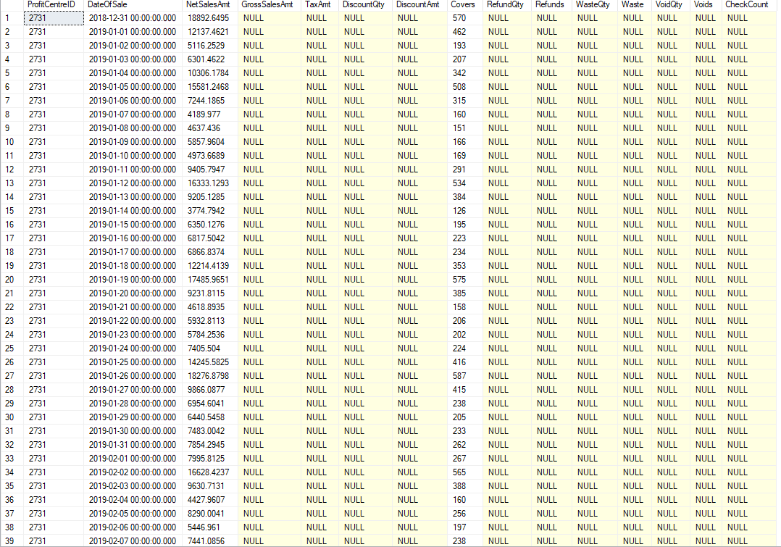

You have this type of data in millions of rows. And you have to analyze it . like : profits , Sales over time , Year-over-year sales .

Seems very tough?

But what if the data is like this.

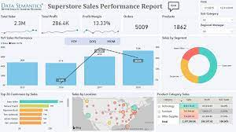

Now you can easily interact with data.

This is what Power BI used for.

* Some Key usage of Power BI
* Connect to various data sources such as databases, spreadsheets, and cloud services.
* Transform and clean data using Power Query, a data transformation and shaping tool.
* Create interactive visualizations such as charts, graphs, and maps to better understand the data.
* Build custom dashboards to track key performance indicators (KPIs) and monitor business performance.
* Share reports and dashboards with others, either within your organization or externally.
* Collaborate with others to co-author reports and work on the same data.
* Access your reports and dashboards from anywhere using a web browser or mobile device.
* Use natural language queries to ask questions and get answers in plain English.
* Incorporate advanced analytics and machine learning models to gain deeper insights from your data.

**Basic life cycle of Power BI**

Power BI has three elements.

Power BI Desktop

Power BI Service

Power BI Mobile.

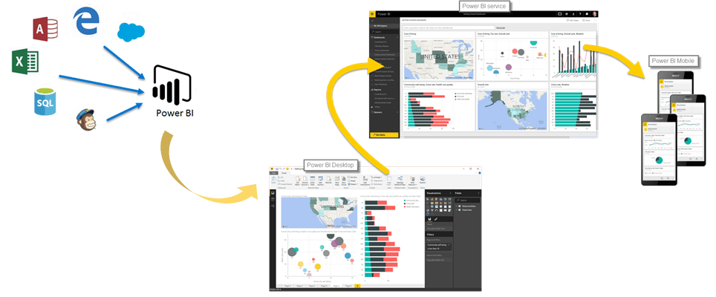

Connect you data source to Power BI Desktop. Here you can create your reports. use various types of visualization and data modeling to create your report.

But Power BI Desktop is a Desktop Application.

**But what if you don’t want to publish or connect data to cloud**

**?**

Here Power BI Report Server comes. you can publish your reports here.

**But what if you want to Embed your reports in your web application**

**?**

Here Power BI Rest API comes. You can not only embed your reports but many more things by using power bi REST APIs.

**But what if you want to see your reports on phone**

**?**

Here Power BI Mobile

Comes. You can easily otimize your reports according to the mobile view

**How can you share your reports**

**?**

Here power BI Service Comes.

Simple publish your reports from desktop to service and now your reports are ready to view and share over internet

Get Data from Data Source.

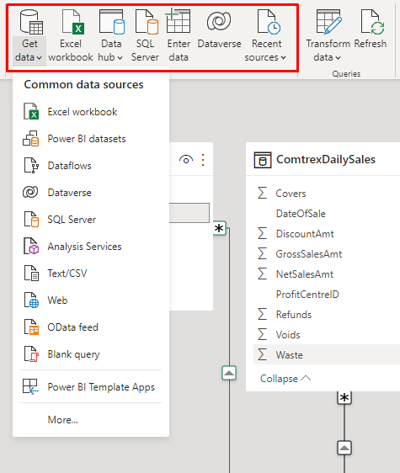

You can connect to various data sources.

* When you are connecting with your data your have to choose the storage mode.

**Storage Modes defines weather or not the Power BI desktop caches the data in In-memory for reports.**

* 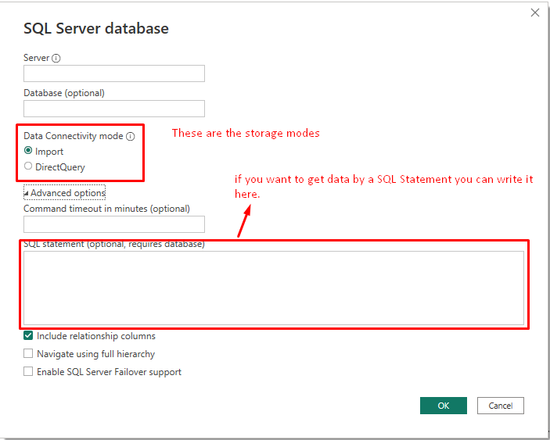

**Expert Advice :**

* **you can change storage mode if you have selected Direct Query.**
* **You can define different storage modes for each table in dataset. (Composite models)**
* **You can’t reverse import mode to Direct Query.**

**Storage Modes**

**Import :**

* Import mode cache you data from data source to in memory cache .
* when you set submit a DAX query to power bi dataset , it will return you the result from the cached data.
* Refresh Required

**Direct Query:**

* When you set storage mode to direct query data is not cached in your memory.
* When you submit a DAX Query , it will return the result by querying the data source directly.
* Refresh not Required.

**Dual :**

* Tables with this setting can act as either cached or not cached, depending on the context of the query that's submitted to the Power BI dataset.
* In some cases, you fulfill queries from cached data. In other cases, you fulfill queries by executing an on-demand query to the data source.

Want a Deep Dive in storage modes.

<https://learn.microsoft.com/en-us/power-bi/transform-model/desktop-storage-mode>

<https://learn.microsoft.com/en-us/power-bi/guidance/directquery-model-guidance>

https://learn.microsoft.com/en-us/power-bi/guidance/composite-model-guidance

**Data Transformation**

you can easily clean up your data and transform the data as per your requirement in Power Query editor.

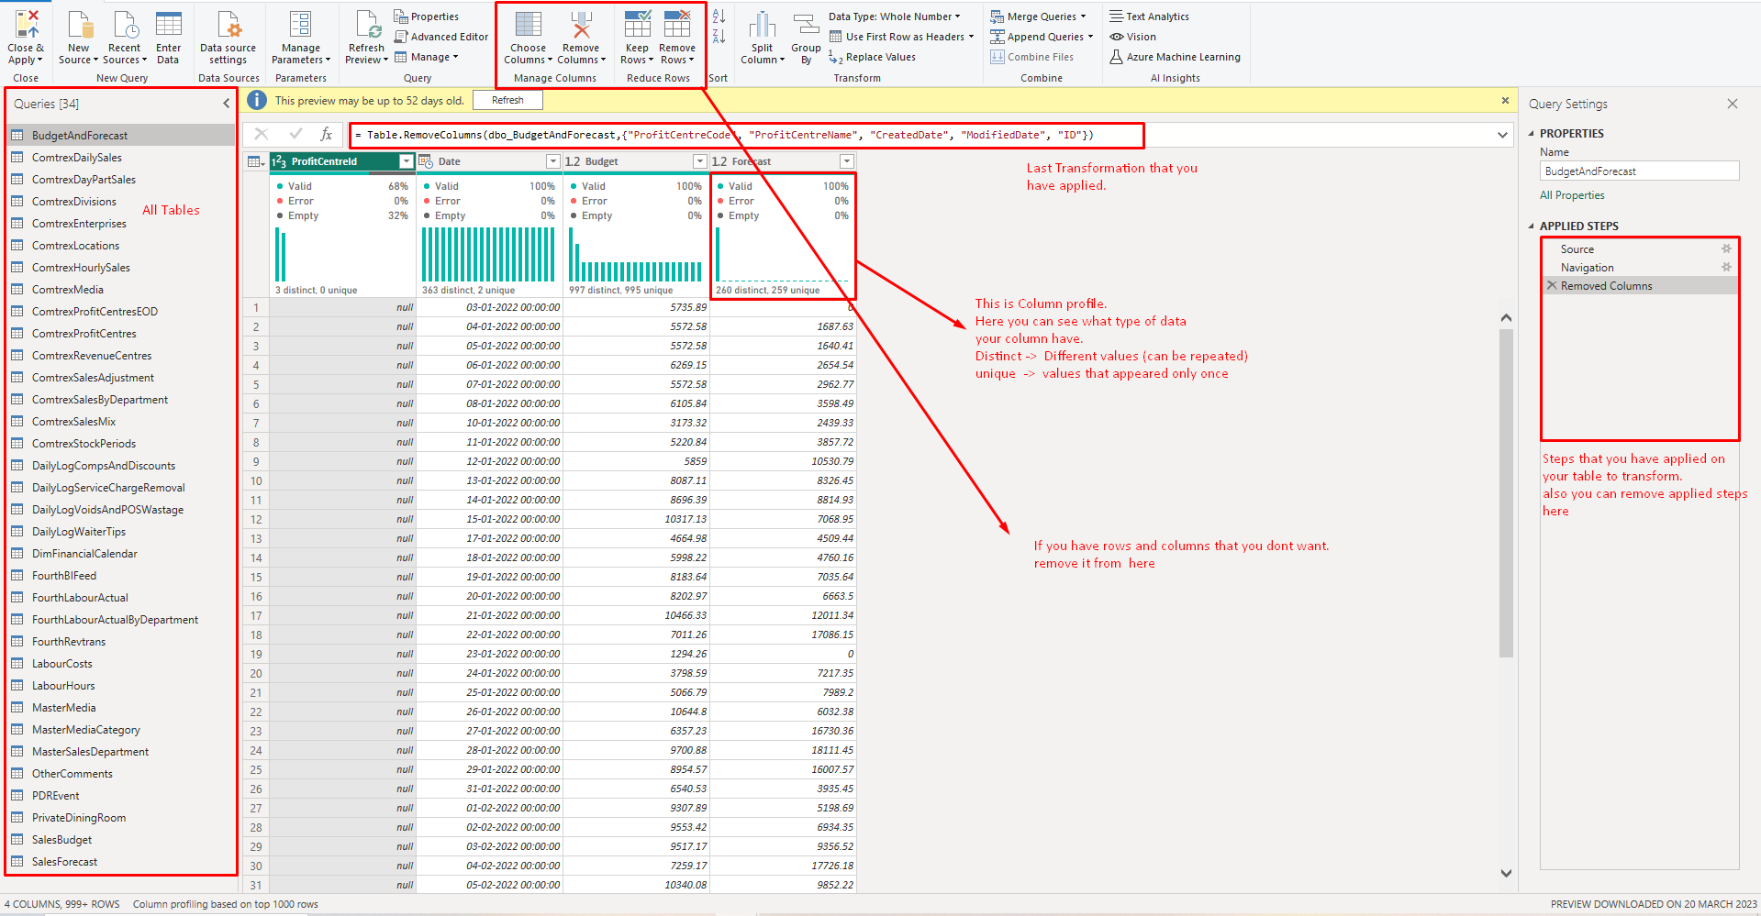

If you some transformation that you cant do by GUI. You can also use Advance Editor. (It uses M Language.)

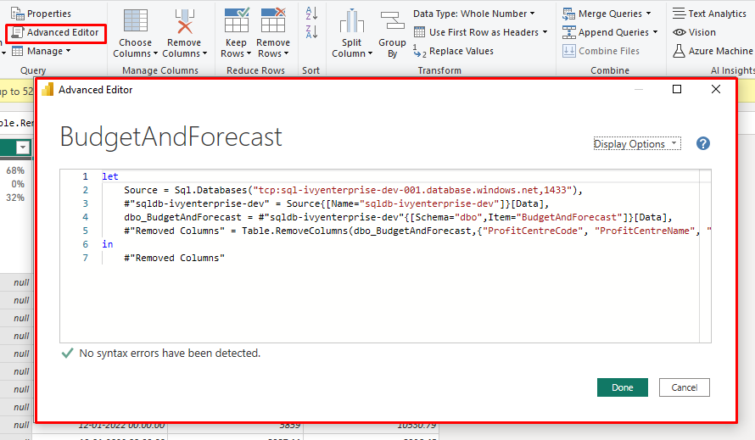

Want to Know Some more About M Language

<https://learn.microsoft.com/en-us/powerquery-m/>

**Sample Power BI Basic Report**

**TrainigReport\_1.1.pbix**

**Data Modeling**

Modeling data is about establishing and maintaining relationships so that you can effectively visualize the data in the form that your business requires.

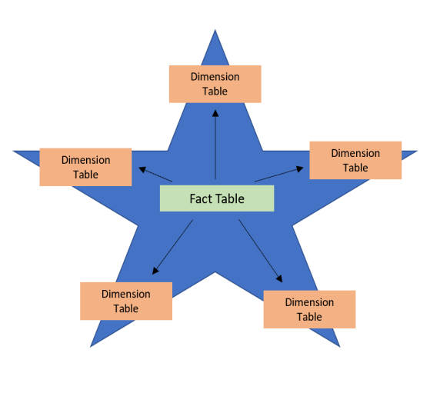

****Fact tables**** :

* contain observational or event data values.
* can contain several repeated values
* Ex. sales orders, product counts, prices

****Dimension tables**** :

* contain the details about the data in fact tables.
* connected to the fact table through key columns.
* Generally contain unique values.

Ex. products, locations, employees, and order types.

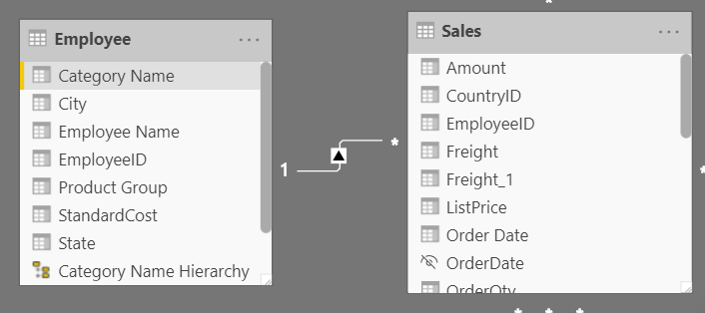

* Because the Sales table contains the sales order values, which can be aggregated, it is considered a fact table.
* The Employee table contains the specific employee name, which filters the sales orders, so it would be a dimension table.
* establish a relationship by **EmployeeID.**

**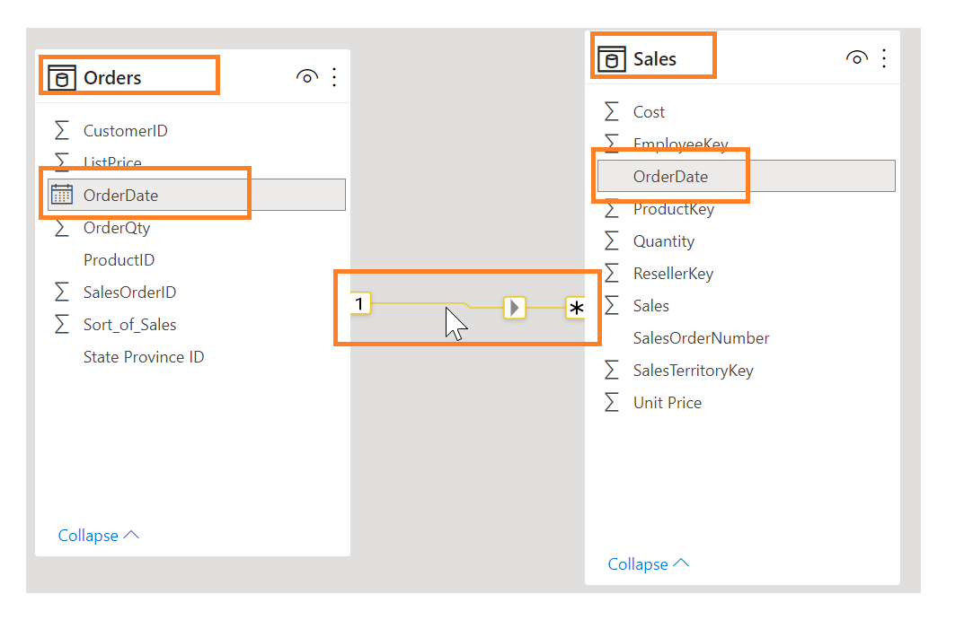**

To manage these relationships, go to ****Manage Relationships**** on the ribbon,

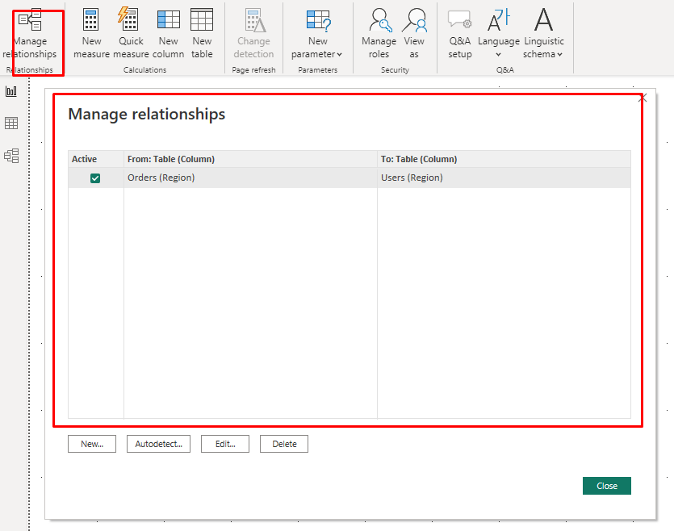

**Hierarchies :**

Power BI hierarchies are a useful structure for drill-down and data exploration in reports. A hierarchy can be created simply and can add great value for you as a developer and end-users for better data analysis.

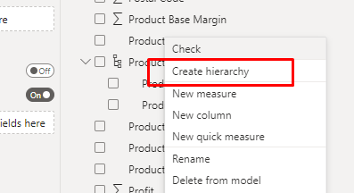

**Relationships**

**Many-to-one (\*:1) / one-to-many (1: \*) relationship**

Describes a relationship in which you have many instances of a value in one column that are related to only one unique corresponding instance in another column.

**One-to-one (1:1) relationship:**

Describes a relationship in which only one instance of a value is common between two tables.

**Many-to-many (.) relationship:**

Describes a relationship where many values are in common between two tables.

## **Cross-filter direction**

Data can be filtered on one or both sides of a relationship.

Follow the direction of the arrow on the relationship between your tables to know which direction the filter will flow. You typically want these arrows to point to your fact table.

<https://learn.microsoft.com/en-us/power-bi/guidance/relationships-bidirectional-filtering>

**DAX(Data Analysis Expression)**

Data Analysis Expressions (DAX) is a programming language that is used throughout Microsoft Power BI for creating calculated columns, measures, and custom tables.

**Use calculated columns**

DAX allows you to create a calculated column that didn't originally exist in the data source.

**Use measures**

Calculated columns are useful, when you are required to operate row by row

## **Differences between a calculated column and a measure**

* calculated column creates a value for each row in a table. For example, if the table has 1,000 rows, it will have 1,000 values in the calculated column.
* Calculated column values are stored in the Power BI .pbix file. Each calculated column will increase the space
* Measures are calculated on demand.
* Power BI calculates the correct value when the user requests it.
* Measures do not add to the overall disk space of the Power BI .pbix file.

# **Use the Calculate function**

The CALCULATE function is your method of creating a DAX measure that will override certain portions of the context that are being used to express the correct result.

Total Sales for 2015 = CALCULATE(SUM('Sales OrderDetails'[Total Price]), YEAR('Sales OrderDetails'[orderdate]) = 2015)

# **Use relationships effectively**

Another DAX function that allows you to override the default behavior is USERELATIONSHIP.

This function is used to specify a relationship to be used in a specific calculation and is done without overriding any existing relationships.

Sales by Ship Date = CALCULATE(Sum(Sales[TotalPrice]), USERELATIONSHIP(Sales[ShipDate],'Calendar'[Date]))

# **Work with time intelligence**

YTD Total Sales = TOTALYTD ( SUM('Sales OrderDetails'[Total Price]) , Dates[Date] )

Total Sales Previous Month = CALCULATE ( sum('Sales OrderDetails'[Total Price]) , PREVIOUSMONTH(Dates[Date]) )

Want to know more about DAX

https://learn.microsoft.com/en-us/dax/

**Tips :**

* if you have too much calculated columns , then it would increase the Refresh time as well as Disk Space.
* Try to make custom columns in Power Query so the Mostly calculations can be done when the target is data source.

**Data Model Optimization**

Performance optimization, also known as performance tuning, involves making changes to the current state of the data model so that it runs more efficiently.

Ensuring that the correct data types are used.

Deleting unnecessary columns and rows.

Avoiding repeated values.

Reducing cardinalities.

Analyzing model metadata.

Summarizing data where possible.

## **Identify report performance bottlenecks**

To achieve optimal performance in your reports, you need to create an efficient data model that has fast running queries and measures.

### **Analyze performance**

You can use ****Performance analyzer**** in Power BI Desktop to help you find out how each of your report elements are performing .

Before you run ****Performance analyzer****, Clear Cache :

****Visual cache :**** (Restart the power BI Desktop )

****Data engine cache**** :  restart Power BI Desktop or connect DAX Studio to the data model and then call Clear Cache.

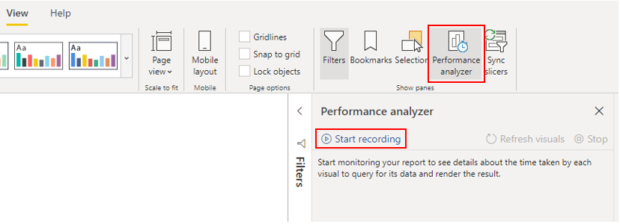

### **Review results**

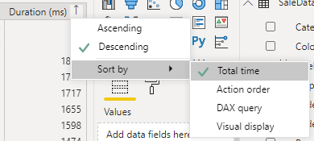

****DAX query**** - The time it took for the visual to send the query, along with the time it took Analysis Services to return the results.

Ex: Count Customers =CALCULATE (

DISTINCTCOUNT ( Order[ProductID] ),

FILTER ( Order, Order[OrderQty] >= 5 ))

****Visual display**** - The time it took for the visual to render on the screen, including the time required to retrieve web images .

****Other**** - The time it took the visual to prepare queries, wait for other visuals to complete, or perform other background processing tasks.

****DAX query**** - The time it took for the visual to send the query, along with the time it took Analysis Services to return the results.

Ex: Count Customers =CALCULATE (

DISTINCTCOUNT ( Order[ProductID] ),

FILTER ( Order, Order[OrderQty] >= 5 ))

****Visual display**** - The time it took for the visual to render on the screen, including the time required to retrieve web images .

****Other**** - The time it took the visual to prepare queries, wait for other visuals to complete, or perform other background processing tasks.

## **Resolve issues and optimize performance**

## **Visuals**

* fewer visuals means better performance.
* Rather than using multiple visuals on the page, consider other ways to provide additional details,

such as drill-through pages and report page tooltips.

* The upper limit for visuals is 100 fields (measures or columns), so a visual with more than 100 fields will be slow to load.
* Can reduce unnecessary fields from the visual

### **DAX query**

* Which measure taking so long to process.
* use DAX Studio to investigate your queries in more detail.
* Check that relationship cardinality properties are correctly configured.
* not import columns of data that you do not need

# **Use variables to improve performance and troubleshooting**

You can use variables in your DAX formulas to help you write less complex and more efficient calculations.

The use of variables in your data model provides :

* ****Improved performance****
* ****Improved readability****
* ****Simplified debugging****
* ****Reduced complexity****

Sales YoY Growth = DIVIDE ( ( [Sales] - CALCULATE ( [Sales], PARALLELPERIOD ( 'Date'[Date], -12, MONTH ) ) ), CALCULATE ( [Sales], PARALLELPERIOD ( 'Date'[Date], -12, MONTH ) ) )

Sales YoY Growth = VAR SalesPriorYear = CALCULATE ( [Sales], PARALLELPERIOD ( 'Date'[Date], -12, MONTH ) ) VAR SalesVariance = DIVIDE ( ( [Sales] - SalesPriorYear ), SalesPriorYear ) RETURN SalesVariance

## **Reduce relationship cardinality**

* always ensure that both of the columns in a relationship are sharing the same data type.

# **Optimize DirectQuery models with table level storage**

# **Implications of using DirectQuery**

* suitable in cases where data changes frequently
* can handle large data

### **Behavior of DirectQuery connections**

* When you load the data, no data is imported into the Power BI Desktop, only the schema is loaded.
* If changes are made to the underlying data, they won't be immediately reflected in the existing visuals in Power BI due to caching. You need to carry out a refresh to see those changes.

### **Limitations of DirectQuery connections**

* ****Performance****

our overall user experience depends heavily on the performance of the underlying data source.

* ****Data transformation****

Compared to imported data, data that is sourced from DirectQuery has limitations when it comes to applying data transformation techniques within Power Query Editor.

* ****Modeling****

Some of the modeling capabilities that you have with imported data aren't available, or are limited, when you use DirectQuery.

* ****Reporting****

Almost all the reporting capabilities are supported

But, when the report is published in Power BI service, the Quick Insights and Q&A features are not supported.

## **Optimize performance**

### Optimize data in Power BI Desktop using **Performance analyzer.**

* identify the queries that are taking a long time to load.

### Optimize the underlying data source

* Avoid the use of complex calculated columns because the calculation expression will be embedded into the source queries.

### Customize the Query reduction options(****File**** ****>**** ****Options and settings**** ****>**** ****Options>Query reduction****)

**Work with visuals**

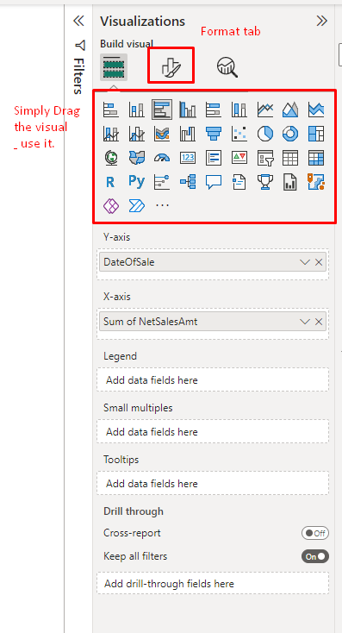

**How to import custom visual**

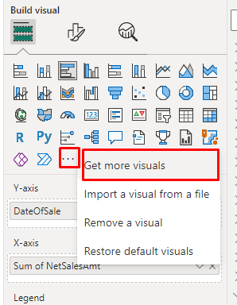

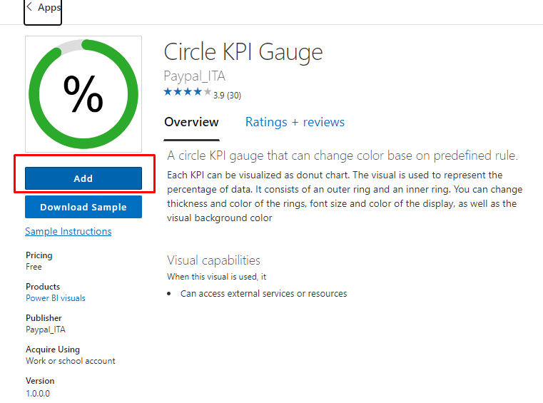

**KPI (**key performance indicator**)**

A key performance indicator is a measurable value that shows how effectively you're meeting your goals. Think of KPIs as your company's scorecard, a way of measuring whether or not you're delivering on your objectives.

KPIs are a great choice:

To measure progress. Answers the question, "What am I ahead or behind on?"

To measure distance to a goal. Answers the question, "How far ahead or behind am I?"

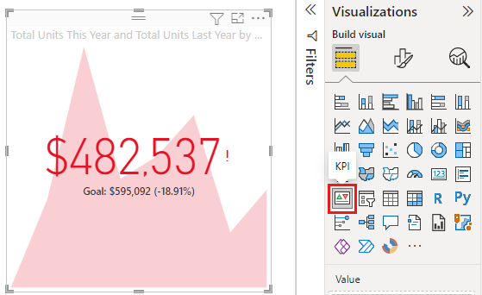

Want to know more

<https://learn.microsoft.com/en-us/power-bi/visuals/power-bi-visualization-kpi?tabs=powerbi-desktop>

**Buttons , Bookmarks & Selection**

**Buttons :**

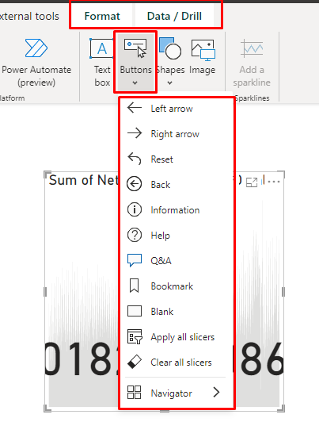

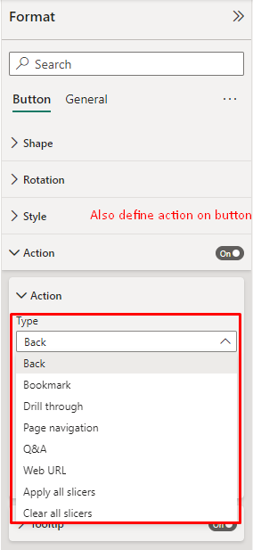

**Bookmarks :**

When you edit a report in Power BI Desktop and the Power BI service, you can add bookmarks to capture the current state of a report page. Bookmarks save the current filters and slicers, cross-highlighted visuals, sort order, and so on.

When you create a bookmark, the following elements are saved with the bookmark:

* The current page
* Filters
* Slicers, including slicer type (for example, dropdown or list) and slicer state
* Visual selection state (such as cross-highlight filters)
* Sort order
* Drill location
* Visibility of an object (by using the ****Selection**** pane)
* The focus or [Spotlight mode of any visible object](https://learn.microsoft.com/en-us/power-bi/consumer/end-user-spotlight)

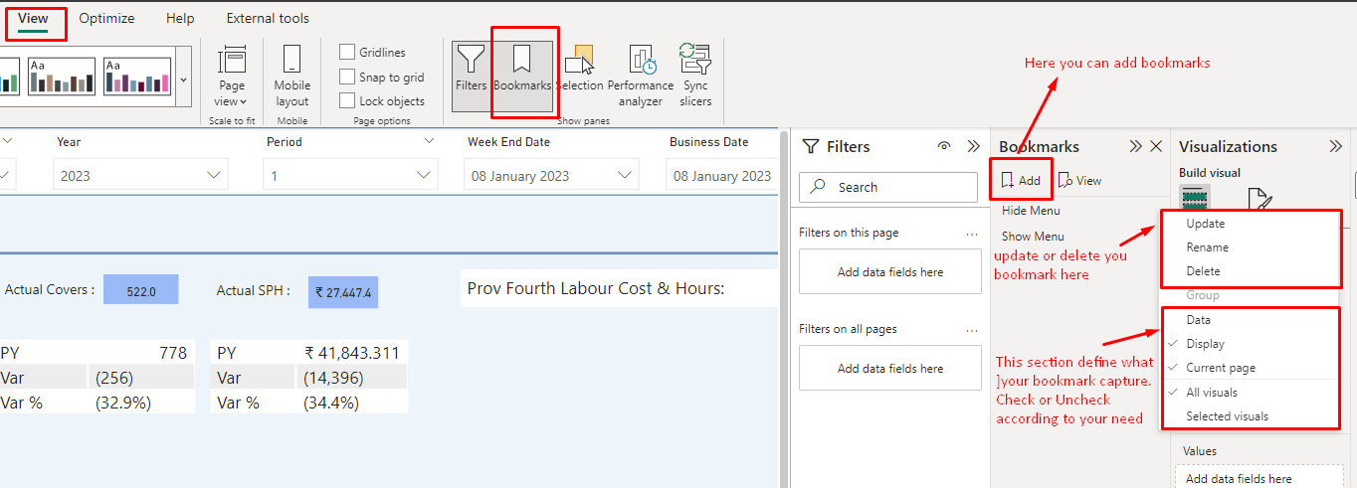

**Selection :**

the Selection pane provides a list of all objects on the current page and allows you to select an object and specify whether it's visible.

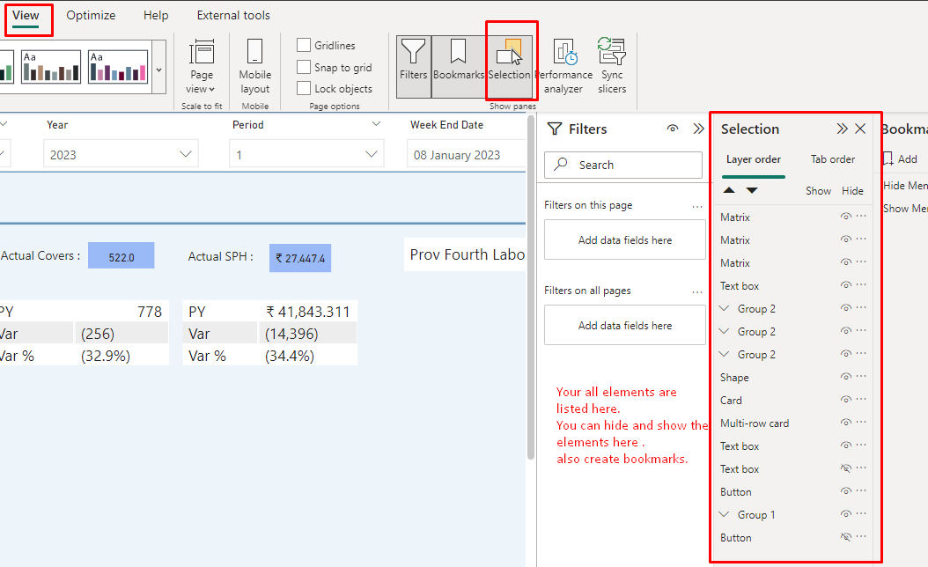

Want to know more about Buttons , Bookmarks and selection

<https://learn.microsoft.com/en-us/power-bi/create-reports/desktop-buttons?tabs=powerbi-desktop>

<https://learn.microsoft.com/en-us/power-bi/create-reports/desktop-bookmarks?tabs=powerbi-desktop>

**Control Visual Interaction**

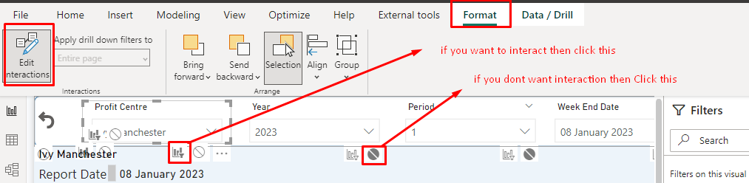

Options for selected visualizations:

* If you want the selected visualization to cross-filter one of the other visualizations on the page, select the ****filter**** icon in the upper right corner of that visualization IMG_256 . You can only cross-filter line charts, scatter charts, and maps. You can't cross-highlight them.
* If you want the selected visualization to cross-highlight one of the other visualizations on the page, select the ****highlight**** icon IMG_257 .
* If you want the selected visualization to have no impact on one of the other visualizations on the page, select the ****no impact**** icon IMG_258 .

Want to know more

<https://learn.microsoft.com/en-us/power-bi/create-reports/service-reports-visual-interactions?tabs=powerbi-desktop>

**Slicing , Filtering & Sorting**

**Slicing :**

Slicers are another way of filtering. They're displayed on the report page, and narrow the portion of the dataset that's shown in the other report visualizations.

Slicers are a great choice when you want to:

* Display commonly used or important filters on the report canvas for easier access.
* Make it easier to see the current filtered state without having to open a drop-down list.
* Filter by columns that are unneeded and hidden in the data tables.
* Create more focused reports by putting slicers next to important visuals.

Power BI slicers don't support:

* Input fields
* Drill-down options

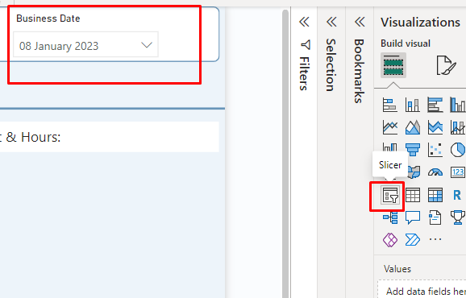

Want to know more

<https://learn.microsoft.com/en-us/power-bi/visuals/power-bi-visualization-slicers?tabs=powerbi-desktop>

**Filtering :**

You can apply filters in the ****Filters**** pane, or [make selections in slicers](https://learn.microsoft.com/en-us/power-bi/visuals/power-bi-visualization-slicers) directly on the report page itself. The Filters pane shows the fields in individual visuals and any other filters the report designer adds.

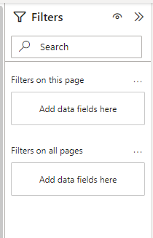

There are four standard types of filters that you create in the Filters pane.

* ****Visual filter**** applies to a single visual on a report page. You see visual-level filters when you select a visual on the report canvas. Even if you can't edit a report, you can select a visual and filter it.
* ****Page filter**** applies to all the visuals on the report page.
* ****Report filter**** applies to all pages in the report.
* ****Drillthrough filter**** With drillthrough in the Power BI service and Power BI Desktop, you create a destination report page that focuses on a specific entity, such as a supplier. From the other report pages, users can right-click a data point for that entity and drill through to the focused page.

Want to know more

<https://learn.microsoft.com/en-us/power-bi/create-reports/power-bi-reports-filters-and-highlighting>

**Sorting :**

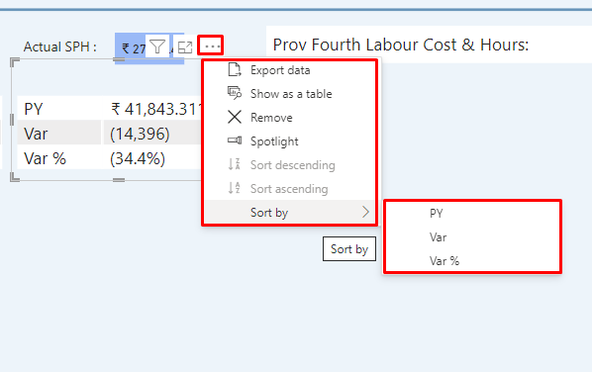

Want to know more

<https://learn.microsoft.com/en-us/power-bi/developer/visuals/sort-options>